**NCFE Level 3 Certificate in Coding Practices**

Introduction

Create- Website Shopping Cart

Designed by:

Kordian Oleksik

Content:

**Create Data Base in** **phpMyAdmin**.......................................................................................................................................2

Structure date base

1. Shopping cart(name of database)
2. *person (table in phpMyAdmin)
3. *address (table in phpMyAdmin)
4. Create relationships between tables above:

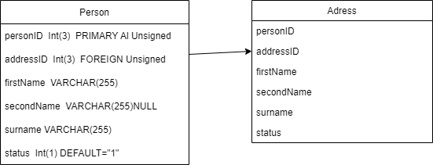

**Create use case**................................................................................................................................2

1. Browse point
2. Add to buscet
3. Check out
4. Payment
5. Confirmation

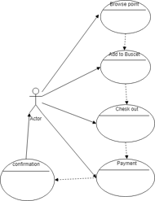

**Create CSS and HTML code in VSC............**.........................................................................................3 **PHP script code and file links in VSC..........**..........................................................................................3

-connect.php

- login.php

- logout.php

- admin.php

- mine.css

- session.php